Palomar Mountain Mutual Water Co., Inc.
Minutes of the Regular Meeting of the Board of Directors

June13, 2015
The meeting was called to order at: 8:35 AM

Directors Present: Martin Marugg, Brett Michael Hauser, Glenn Borland, John Lesac, Walt Johnston and Mark Thompson.

Directors Absent: Brian Wagner

Also present: Mike Probert [Operator], Linda Thorne [Office Manager, Joanne Marugg [Past President]

The minutes of the April meeting were approved.

The May meeting was cancelled due to bad weather.

.

Operator’s Report: [Mike Probert]
[See Operator’s Diary and well and pump data]

Well June 2015 Jan 2015 June 2014

Darby 48’ [dry] 37’ 38’
Pedley #3 30.2’ 31.2’ 27’
Pedley #5 27’ 26’ 26’

Tank levels: 60K gallons 65K gallons
Water usage: Avg. 8900 g/d

Annual meter readings complete: It took Mike 9 hours to do it alone.

Coliform absent

Water testing complete.

4-11-15: Cloudy water. There was a leak in the transmission line at the bottom of pipeline road.
During the day the water in the line would drain off. When the pumps started again it pushed disturbed water into the tanks…Mike made the repair and put 1 gallon of food grade bleach to the big tank. The line was then flushed. It took three days for the water to clear. We lost about 1,500 gallons/day.

4-13-15: Well samples: Mike drew necessary samples from wells 3 and 5. We are required to do major testing this year. Sample results are in and will be reported in next year’s CCR. Our water quality looks fine.

4-18-15: Wild land fire: There was fire on the East Grade Road. The fire was put out and tenders were filled at the fire Department with PMMWC water. About 3K gallons.

5-4-15: Road grading issue: Mark Sowards called Mike to report an exposed pipe [Happy Holler]. There is a 2” exposed line and much erosion due to over-grading of the road. This will be repaired soon.

5-11-15: Happy Holler pipeline relocation: Tom, Mike and a backhoe relocated the “Happy Holler” pipe in the road. It is down a depth of 2’ from the old location.

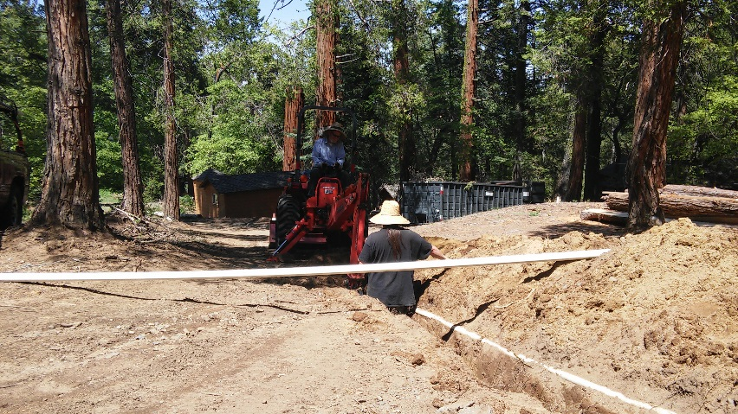

5-25-15: Zone A leak: Again. This makes about 8 repairs in a 40’ section. Mike plans to do a major repair in this section this summer.

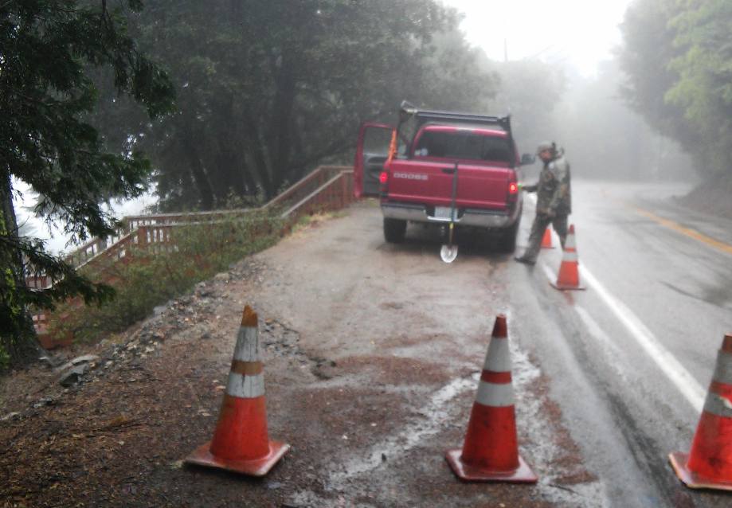

Zone A leak

5-25-15: Annual Meter Readings: Completed in 9 hour by Mike alone! A serious leak was found of the Dirk’s property.

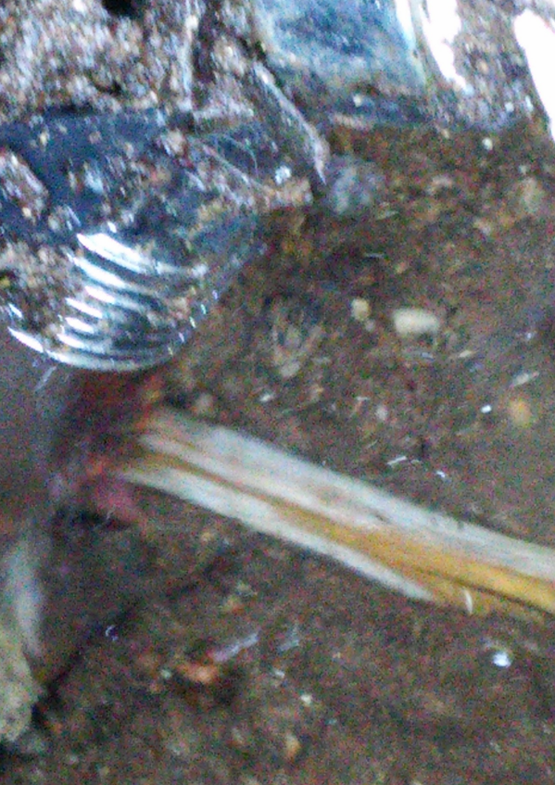

5-30-15: Fallen Oak Tree: After another high overnight usage, Mike found that an Oak tree had fallen
and broke the line on our side of the meter. The tree landed on meter box #41 and broke the line under the box. With Tom’s help, Mike removed the tree and repaired the line.

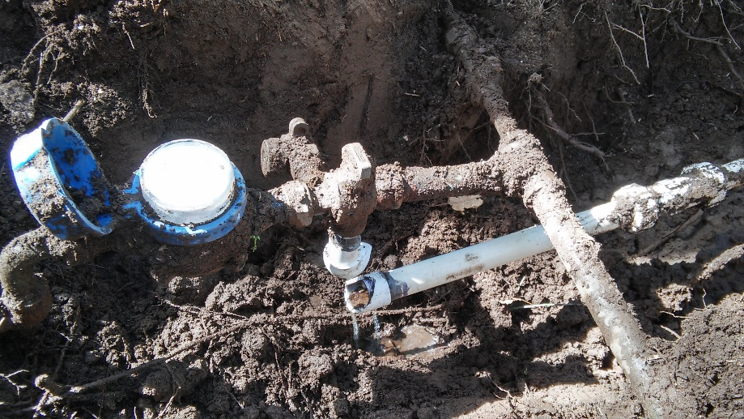

6-2-15: Broken Distribution Line: Robert Carlyle called Mike to report that he had broken a water line while cleaning up the Noon property [APN#_____ ]. The line was on the homeowner’s property. Mike turned off the meter.

6-4-14: Broken water line: Ron Bowen broke a water line when installing a pole for the homeowner {Rowe Property|. They had previously called Mike for an O.K. The line was in an unexpected place. Mike tracked a line that turned out be an old abounded. While trying to make the repair, another line was broken. Mike made these repairs as well.

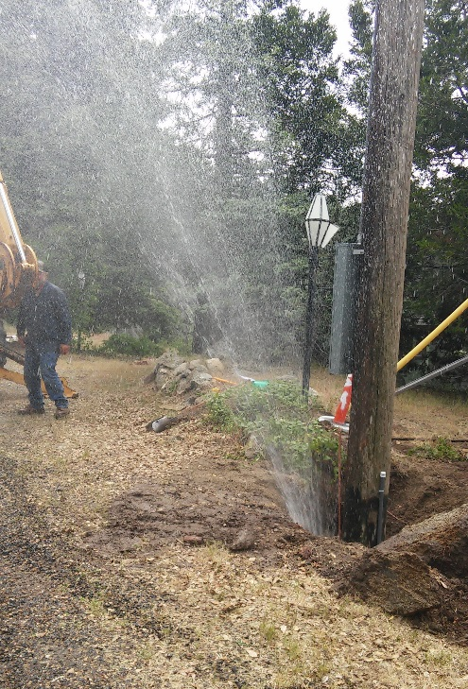

Telemetry Down: The telemetry failed during the time of the cloudy water leak. John Lesac fixed the telemetry by using another computer and various magic.
Telemetry is up and running again!

Fire Department: Cliff Kellogg has retired. Mike has no good contact at present. Brett will contact the Fire Department and try to set up communication with whoever is in charge.

New tanks: The warranty on our tank liners will be up next year. We may have to consider new tanks. Mike would like a 100K tanks someday- probably fairly soon. This will cost approximately $100,000.
The money for this would come out of our reserve account [Approx. $200,000]. The Board discussed whether we need new assessments to keep that reserve at this level

Secretary’s Report: [Glenn Borland – Linda Thorne]

Share transfers and Pending Escrows: Please see Water share transfer spreadsheet as part of these minutes.

Treasurer’s Report: Brett Michael Hauser
See financials included with these minutes

Brett reviewed the financials: from April: Most of the January bills have been paid except for five shareholders who have large unpaid balances. All of these meters have been locked off and we are collecting interest on the debt.

One shareholder on the payment plan is not keeping up with her obligation. We will address this at the next meeting.

Old business/New Business:

Financial review: Linda presented a review of the financials over the last nine years. Please see report as part of these minutes. Basically we are in very good shape. We have about $200K in our reserve account and have enough income to cover our running expenses. , thanks to the good management of the Board under the direction of the Maruggs. Of interest is that we are not seeing an increase in revenues from water despite increased rates. We now have many more weekenders and fewer full time residents.

Also of note: During the 2013-2014 fiscal year we pumped 3.18 million gallons and sold 2.76 million gallons. This means our system is at 87% efficiency. This is great for an old water system. Also of note, with our current rate of usage, it costs us about $100 to donate 100K gallons to the Fire Department.

We will add more date to this report when we get the 2014-2015 fiscal year financials.

Water Bills: The water bills have been prepared and are with our accountant. They will go out at the end of July. We used Brian’s new software to prepare the bills. THANK YOU BRIAN!

Since there was no special assessment this year, Linda had to separate out water users from non-water users because all shareholder have to get information, proxy, and Newsletter and Contact info. form.
All shareholders will receive a mailing.

Tom Scott’s Request for well data: [See E-mail as part of these minutes]. The Board agreed to let Tom Scott of UCR use the data for research only.

Kathy Landy’s letter about tank clean-up site: [see letter as part of these minutes]. Kathy Landy thinks the Tank site needs to be cleaned up vegetation wise. The Board agreed to ask Tom Scott to evaluate the property and tell us what needs to be done to preserve the environment.

New Directors: We will need two new directors to replace retiring directors.

The meeting was adjourned at: 10:20 A.M.
Next Meeting: 8:30 A.M. July 11, 2015

Respectfully submitted:
Linda Thorne [Office Manager]
June 14, 2015

