Palomar Mountain Mutual Water Co., Inc.
Minutes of the Regular Meeting of the Board of Directors

July 11, 2015
The meeting was called to order at: 8:3o AM

Directors Present: Martin Marugg, Brett Michael Hauser, Glenn Borland, John Lesac,

Brian Wagner and Mark Thompson.

Directors Absent: Walt Johnston
Also present: Mike Probert [Operator], Linda Thorne [Office Manager, Joanne Marugg [Past President], Sue Hanson, Charly Caven and Kent Miller

Kent came to visit the meeting and expressed an interest in running for the Board.

Charly is a new shareholder and came to get information on the water company.

Sue has concerns about the mandatory water restrictions. She is hauling water for her plants. Sue also presented a letter to the Board. We will address this at the next meeting.
She has also volunteered to run for the Board.

The minutes of the June meeting were approved.
.

Operator’s Report: [Mike Probert]
[See Operator’s Diary and well and pump data]

Well July 2015 June 2015 June 2015
Darby 48’ [dry]
Pedley #3 33.1 30.2’ 26.3’
Pedley #5 33.9’ 31.4’ 28.7’

Tank levels: 60K gallons 65K gallons
Water usage: Avg. 8800 g/d
Chlorine levels: 0.5ppm at the tank site

Coliform absent

.

6-26-15: High Water usage. The leak was in Zone A, so Mike had to turn of water to the Fire Department for repair. He had trouble finding the person in charge.

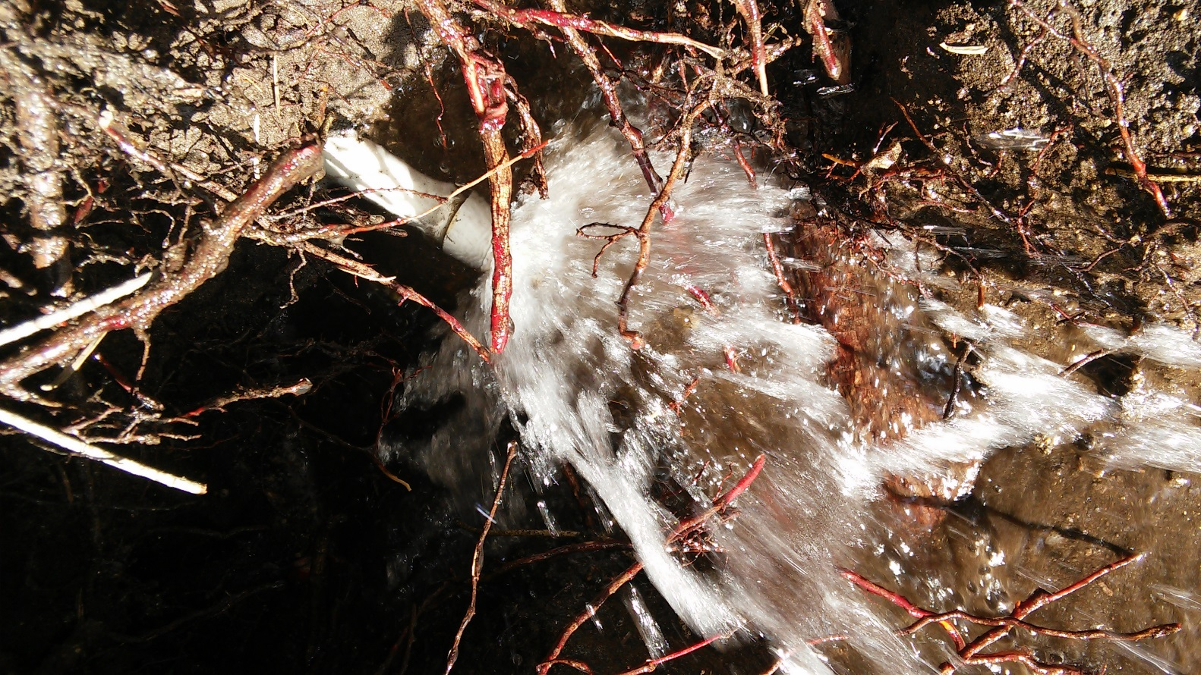

6-29-15: Well #3 failed. The starter coil failed.
6-30-15: Stehly repair: Stehly repaired the coil.

7-3-15: Fire Department meeting: Mike met with Christina Williamson [Battalian Chief for Cal Fire], Captain Jen [In chage of PMVFD], Suzanne Leininger [President of the PMVFD Board] and Cliff Kellogg [pevious PMVFD Fire Chief]. Christina thinks she might be able to get a grant to help us upgrade our system

Topics Discussed:

Tanks: Our tank liners have only 2 to 3 years left, although they may last longer. Replacing our 40 gallon water tank with an 80 gallon tank would help solve our storage problems

Zone A and line to the PMVFD: Zone A needs constant repair. A ¾” line supplies the PMVFD. The PMVFD has lots of pressure, but low volume. This line needs to be replaced.

Standpipes: These cannot support Fire Department use. Mike must be on hand if standpipes are used in emergencies.

Sue Hanson asked about solar panels for the pumps. Mike explained that this was not feasible because Pedley Valley does not have enough sun exposure.

Secretary’s Report: [Glenn Borland – Linda Thorne]

Share transfers and Pending Escrows: Please see Water share transfer spreadsheet as part of these minutes. Zieber and Tainer are currently in escrow.

The water bills have been mailed. They are not due until September1. Not everyone had a water bill but everyone received the newsletter and a proxy.

Linda thanked Brian for his great job with software. Without this billing would have been a complete mess.

Debbie Thicksten is retiring from Rothermel, but she will continue to do the water company accounting.

Treasurer’s Report: Brett Michael Hauser
See financials included with these minutes

Brett reviewed the financials and the aged receivables, most bills have been paid except for the long time hold outs. We will collect this money upon the sale of the property.

Our next financials will be for the end of the fiscal year. We will have copies of these for the annual meeting.

Old business/New Business:

Clean up electrical panel: The electrical panel that runs the pumps needs cleaning up and an upgrade. .This is needed when the pumps need to be controlled manually.
Stehly Brothers can do this.

Well Data: Linda has sent old well data to Tom Scott at UCR. He will use the data for determining ground water impact on Oak trees. When Linda has time she will pull out current data.

CERT: According to , CERT will probably be leaving the mountain and joining the Valley Center group.

Mandatory Sign: John Lesac will post information about the “mandatory water restriction” on our web site, per Sue Hanson’s request. There have been problems with our web site access from mobile phones. John will also check into this.

The visitors were excused:

Aged receivables: Discussion about how to collect back payments from shareholders who are not current on their bills and still have their meter turned on.

Fire Department: Cal Fire fighters are living in the Community Center house and are using a lot of water for showers, etc. The Water Company has been donating 100 K gallons/year to the PMVFD Volunteer Fire Department. Now Cal Fire is in charged and needs more water. The Board will watch this situation.

New Directors: We will need two new directors to replace retiring directors. We have two shareholders that have expressed a desire to serve. There may be more if we can find them.

Annual Meeting: We will need to check with the Fire Department to make sure that we can hold our annual meeting there.

Next Meeting: The Maruggs will be out of town for our next scheduled meeting and so we will hold the meeting on the third Saturday of August.

The meeting was adjourned at: 10:30 A.M.
Next Meeting: 8:30 A.M. August 15, 2015

Respectfully submitted:
Linda Thorne [Office Manager]
August 4,, 2015

