Palomar Mountain Mutual Water Company, Inc.
Annual Shareholders Meeting
September 2, 2019 at 10:00 A.M., PMVFD Fire Station

DRAFT-Unapproved

Minutes

Establish a quorum –A quorum was not established. There were 72 members represented by proxies and presence.

97 shares represented by person or proxy are required to establish a quorum.

The minutes of the 2018 Shareholders Annual meeting were approved. Glen Borland moved and the Board approved and shareholders approved.

Opening Ceremonies

Meeting called to order at 10:00 AM: President Joanne Marugg

Introduction of the Board and staff: Joanne Marugg. Joanne introduced and thanked the current Directors and employees for their service.

Joanne Marugg, Brett Michael Hauser, John Lesac, Glenn Borland, Brett Michael Hauser, Kent Miller and Brian Wagner and Walt Johnston were in attendance. Systems Operator Mike Probert and Linda Thorne [Office Manager] and Martin Marugg [past President] were also in attendance.

Operator’s Report – Mike Probert

Tank Installation: Mike intended to show a video of the tank site installation, but it could not be shown because of technical problems. The DVD will be a part of these minutes. We will also try to transfer it to the web site.

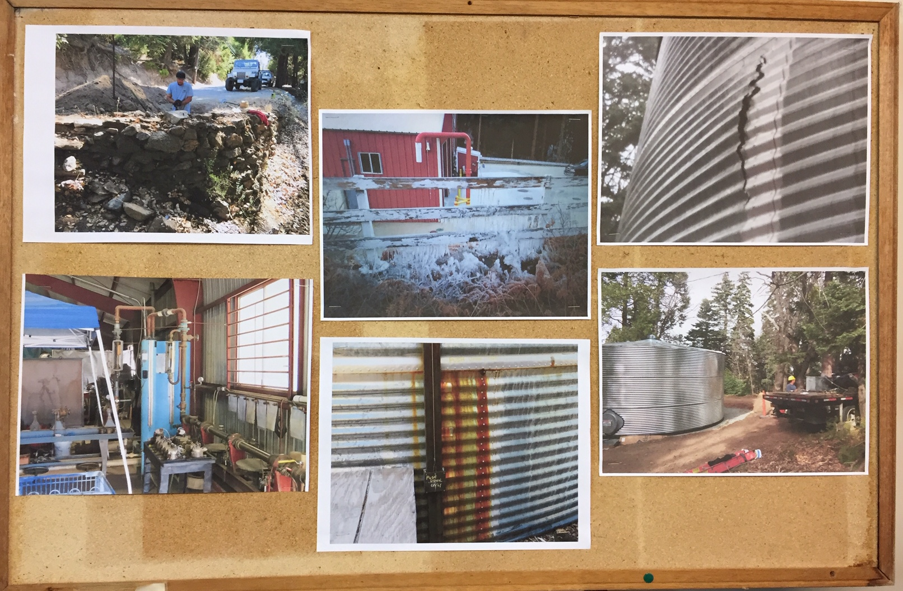

The tank is now installed and was under budget. It took 4 ½ days to install and was ahead of schedule. Everything went smoothly. Well Levels are way up because of the winter rains. Darby well is still too low to pump, however. It will need testing before we put it on line. Note: Darby well is only a 50 feet deep. It is in a different location than the Pedley wells.

John presented a graph of the well levels.

Leaks: These were reported and repaired by the property owners. Mike thanked shareholders for reporting personal leaks. This prevents leak searches.

New Shareholders: John Lesac
See list of the new shareholders included as part of these minutes.

John read the list of new shareholders. There were 16 new members including interfamily transfers.
Only one new member came to the meeting, Tony Jaramillo. Tone introduced himself.

Treasurer’s Report –Brett Michael Hauser
Please see a copy of the fiscal year financials included with these minutes.

Brett reviewed the financials: This year’s Income = $99,096 Last Year’s Income = $ 87,327.
Expenses = $100,022 `Expenses = $90,110

Total assets = $390.767

We have used some of our assets to pay for the new tank. $200.395 of the current assets are in a money market account. This is our reserve account.

Questions and discussion by shareholders

Scott asked how long the water in the tanks would last if they were not supplies. Mike said that we have 67K gallons in storage and we use 4 K to 5 K gallons a day under emergency conditions. Normally use about 8.5 K gallons/day depending on the season.

Linda Thorne [Office Manager]
Linda discussed office issues including billing, share transfers, etc. while Mike and John tried to get the vi9deo to work.

Bonnie Spear [Communications]

Bonnie put in a call for E-Mail contact information. She is developing a list so that we can send out notifications to shareholders this way.

Candidates for the New Board
The Board will stand as is since we cannot have a legal vote—no quorum.

The meeting was adjourned at 10:40 AM.

Respectfully submitted
Linda Thorne [Office Manager]
September 2, 2019

